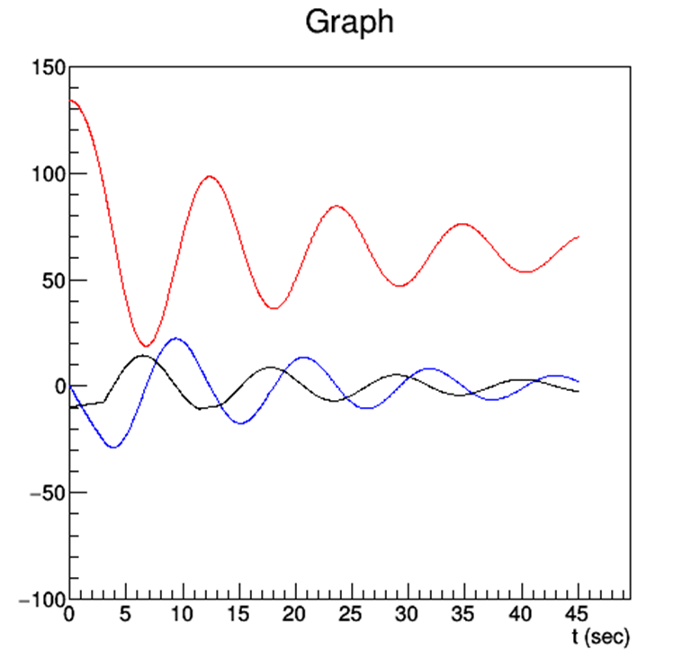

Height versus time in red

Velocity versus time in blue

Acceleration versus time in black

